SCHOOL OF COMPUTER SCIENCE AND ARTIFICIAL INTELLIGENCE |  |  |  |  | DEPARTMENT OF COMPUTER SCIENCE ENGINEERING
Program Name: B. Tech |  |  |  | Assignment Type: Lab |  |  | Academic Year:2025-2026
Course Coordinator Name |  |  |  | Venkataramana Veeramsetty
Instructor(s) Name |  |  |  | Dr. V. Venkataramana (Co-ordinator)  Dr. T. Sampath Kumar  Dr. Pramoda Patro  Dr. Brij Kishor Tiwari  Dr.J.Ravichander  Dr. Mohammand Ali Shaik  Dr. Anirodh Kumar  Mr. S.Naresh Kumar  Dr. RAJESH VELPULA  Mr. Kundhan Kumar  Ms. Ch.Rajitha  Mr. M Prakash  Mr. B.Raju  Intern 1 (Dharma teja)  Intern 2 (Sai Prasad)  Intern 3 (Sowmya)  NS_2 ( Mounika)
Course Code |  |  | 24CS002PC215 | Course Title |  | AI Assisted Coding
Year/Sem |  |  | II/I | Regulation |  | R24
Date and Day  of Assignment |  |  | Week10 - Monday | Time(s)
Duration |  |  | 2 Hours | Applicable to  Batches
AssignmentNumber:20.1(Present assignment number)/24(Total number of assignments)
 | Q.No. | Question |  |  |  |  |  | Expected Time  to complete
 | 1 | Lab 20 – Security Testing: Identifying Vulnerabilities in AI-Generated Code  Lab Objectives:  - Understand how to test AI-generated code for common security vulnerabilities.  - Learn to apply secure coding principles while analyzing AI outputs.  - Practice detecting risks such as SQL injection, XSS, hardcoded credentials, and weak encryption.  - Enhance code reliability and safety by using AI for secure refactoring.  Task 1 – Input Validation Check  Task:  Analyze an AI-generated Python login script for input validation vulnerabilities.  Instructions:  - Prompt AI to generate a simple username-password login program.  - Review whether input sanitization and validation are implemented.  - Suggest secure improvements (e.g., using re for input validation).  Expected Output:  - A secure version of the login script with proper input validation.  Prompt:  - Generate a secure Python login system where the username and password are created dynamically by the user, with input validation and password hashing.  Code:  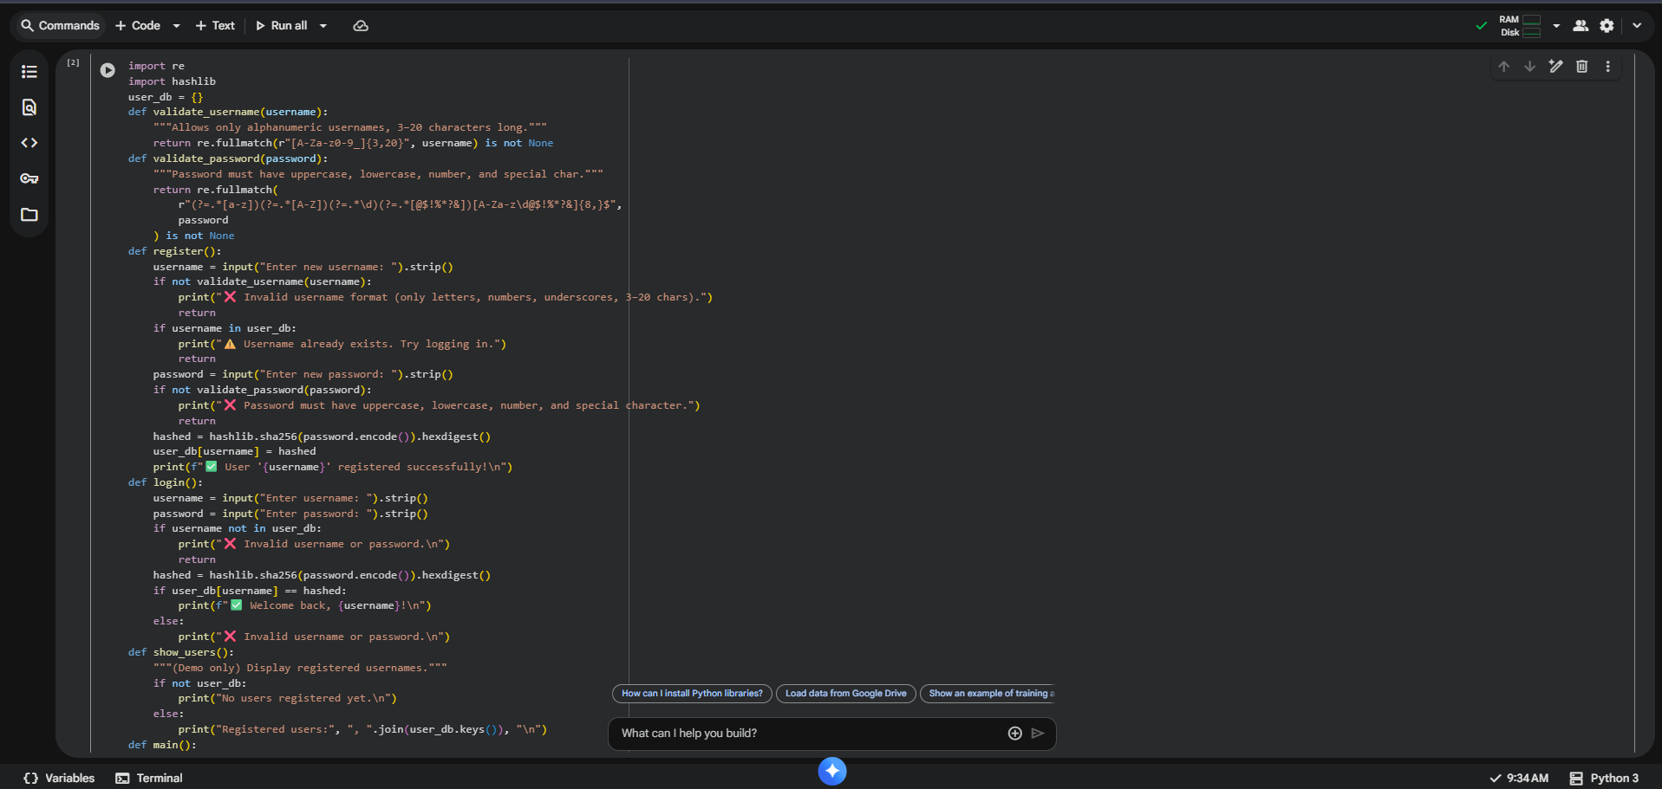  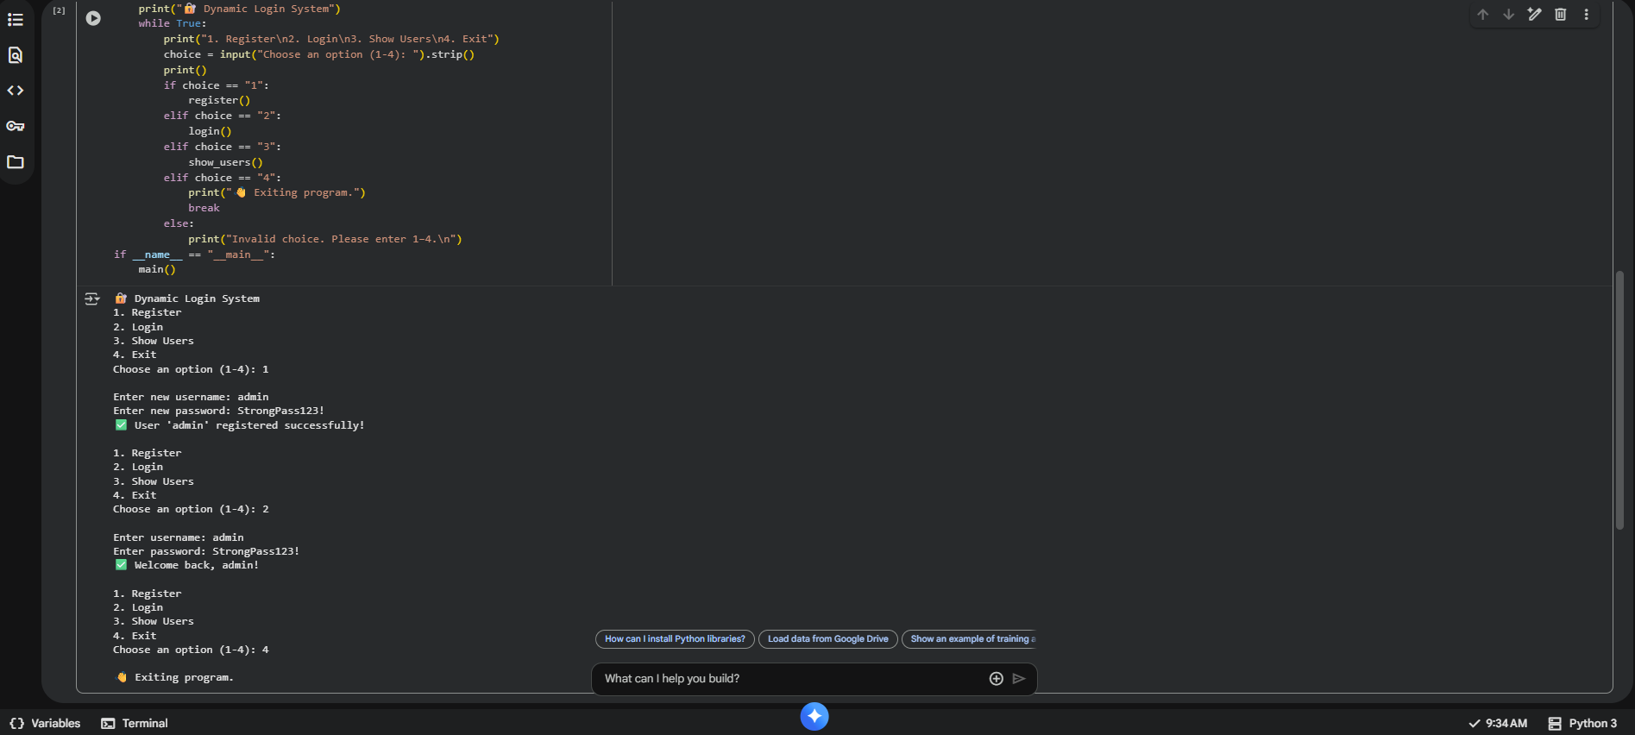  Observation:  - This Python code implements a basic user registration and login system using a dictionary for storage. It includes validation for usernames and passwords, password hashing using SHA-256, and a simple command-line interface.  Task 2 – SQL Injection Prevention  Task:  Test an AI-generated script that performs SQL queries on a database.  Instructions:  - Ask AI to generate a Python script using SQLite/MySQL to fetch user details.  - Identify if the code is vulnerable to SQL injection (e.g., using string concatenation in queries).  - Refactor using parameterized queries (prepared statements).  Expected Output:  - A secure database query script resistant to SQL injection.  Prompt:  - Generate a secure Python script using SQLite that accepts multiple dynamic user inputs to fetch user details safely.  Ensure it uses regex-based input validation and parameterized SQL queries to prevent SQL injection.  Code:  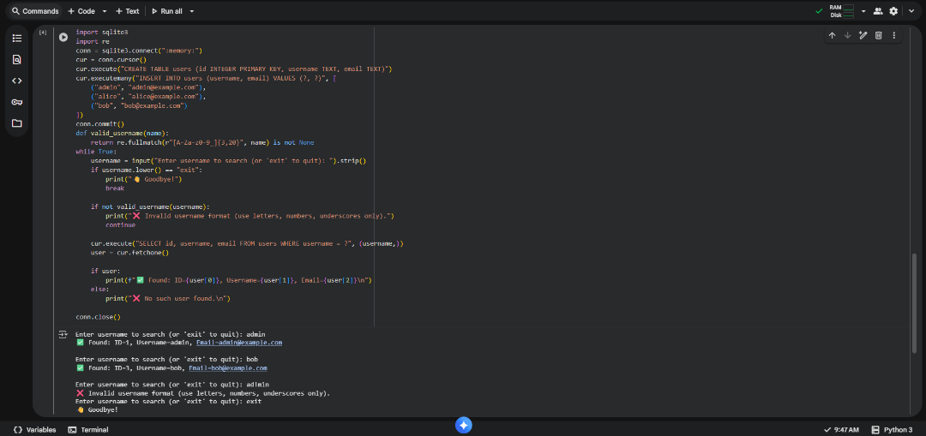  Observation:  - This Python code demonstrates searching a SQLite database for a user by username. It connects to an in-memory database, creates a 'users' table, inserts sample data, and then allows the user to input a username to query the database. The code also includes basic input validation for the username.  Task 3 – Cross-Site Scripting (XSS) Check  Task:  Evaluate an AI-generated HTML form with JavaScript for XSS vulnerabilities.  Instructions:  - Ask AI to generate a feedback form with JavaScript-based output.  - Test whether untrusted inputs are directly rendered without escaping.  - Implement secure measures (e.g., escaping HTML entities, using CSP).  Expected Output:  - A secure form that prevents XSS attacks.  Prompt:  - Create an HTML feedback form with JavaScript that securely processes user input without allowing any XSS injections. Ensure the output is safely rendered by sanitizing or escaping all untrusted input before displaying it.  Code:  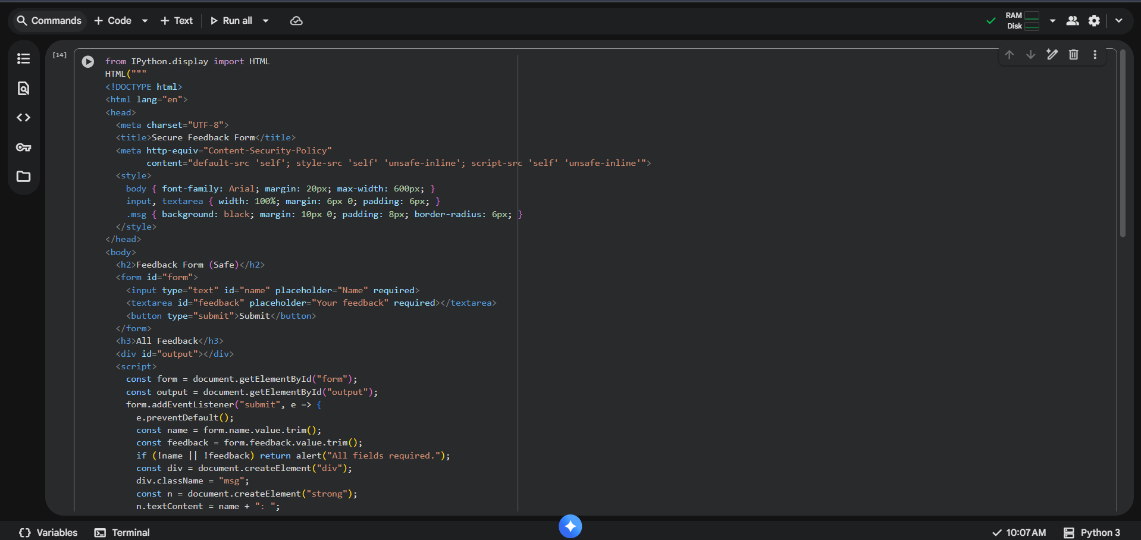  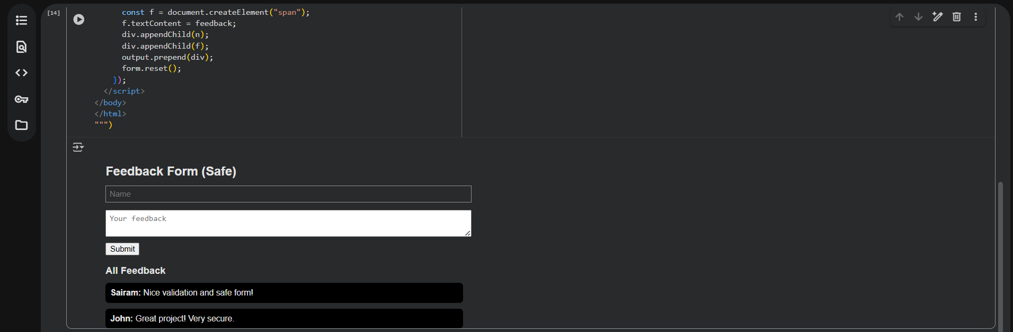  Observation:  - This code uses IPython.display.HTML to render an HTML feedback form within the notebook output. The form includes basic client-side validation and appends submitted feedback to the display area without server-side processing.  Task 4 – Real-Time Application: Security Audit of AI-Generated Code  Scenario:  Students pick an AI-generated project snippet (e.g., login form, API integration, or file upload).  Instructions:  - Perform a security audit to detect possible vulnerabilities.  - Prompt AI to suggest secure coding practices to fix issues.  - Compare insecure vs secure versions side by side.  Expected Output:  - A security-audited code snippet with documented vulnerabilities and fixes.  Prompt:  - Perform a security audit on an AI-generated dynamic input code (e.g., login form) to identify vulnerabilities such as SQL injection, plaintext passwords, and missing validation.Then, prompt the AI to suggest secure coding practices and display insecure vs. secure versions side by side for comparison.  Code:  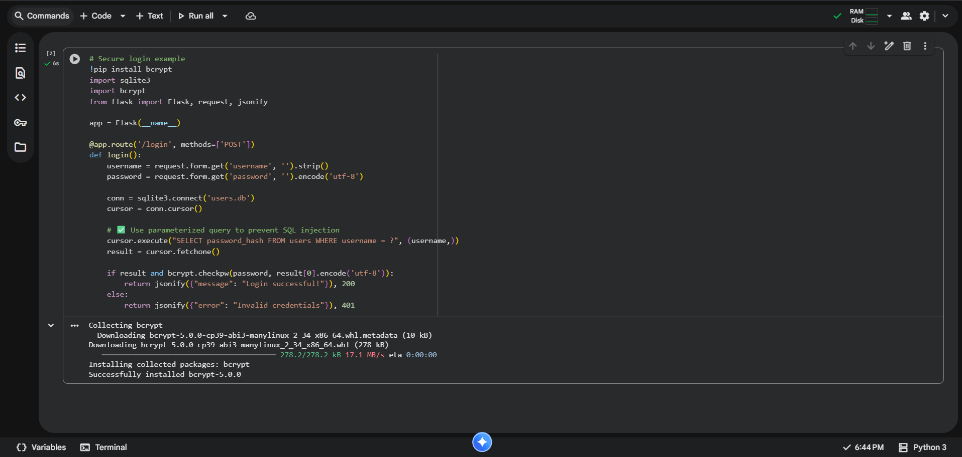  Observation:  - This Flask application provides a secure user login endpoint (/login) that accepts a username and password via a POST request. It leverages bcrypt for secure password verification against a SQLite database and incorporates parameterized queries to prevent SQL injection.  ✅ Deliverables (For All Tasks)  - AI-generated prompts for code and test case generation.  - At least 3 assert test cases for each task.  - AI-generated initial code and execution screenshots.  - Analysis of whether code passes all tests.  - Improved final version with inline comments and explanation.  - Compiled report (Word/PDF) with prompts, test cases, assertions, code, and output. |  |  |  |  |  | Week10 - Monday

